**One-Stop Shop is online**

**16Feb**2019

An important achievement of the Agency, the railway sector and national authorities: The One-Stop Shop (OSS) is available to applicants as the single entry point for new tasks of the Agency.

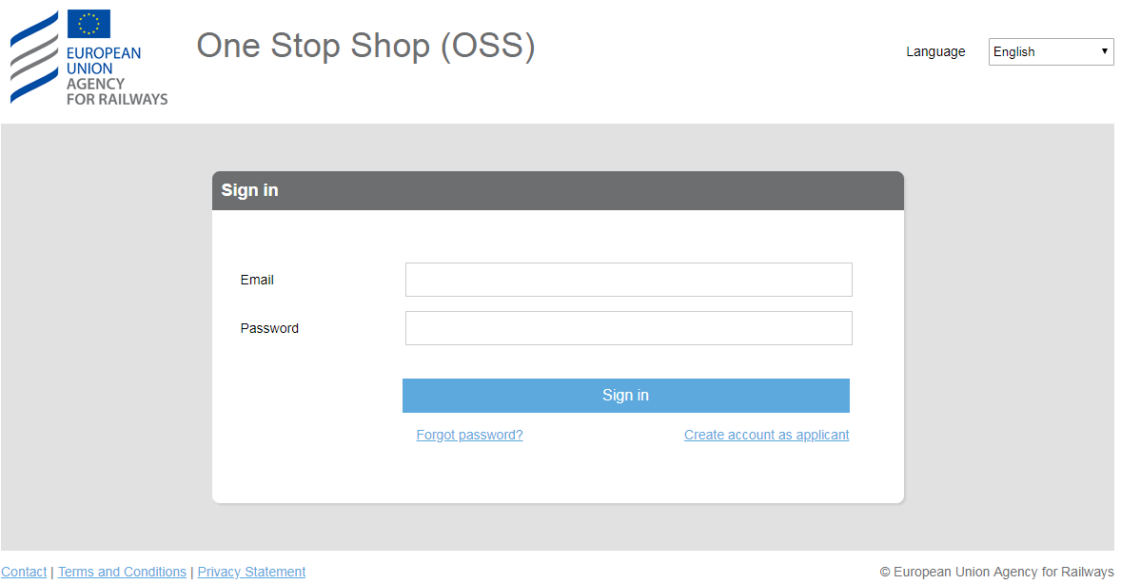

We are proud to announce that the One-Stop Shop (OSS) is from now on accessible online at this address: [oss.era.europa.eu](https://oss.era.europa.eu).

This milestone was made possible due to extensive collaboration and consultation with the sector and the member states during the past years.

The OSS will be the single entry point for the new tasks that the Agency will be delivering as of June 2019.

As a first step, the OSS allows applicants to register and prepare its revised application(s) for vehicle (type) authorisation via the web tool.

The OSS has been designed based on a user-friendly technology and its use is supported by the OSS team via a specific guidance document available [here](https://www.era.europa.eu/sites/default/files/applicants/docs/oss_user_guide_for_va_applicants_en.pdf). **It is recommended to use an updated Google Chrome or Mozilla Firefox browser, as using others might result in poor performance or errors.**

Should you have questions or encounter problems please contact us via email at [ServiceDesk](mailto:ServiceDesk@era.europa.eu).